*OpenShift Integration with CloudForms*

Step 1:- Run the below command to generate a token. Make sure you are logged in as (system:admin)

***# oc sa get-token -n management-infra management-admin***

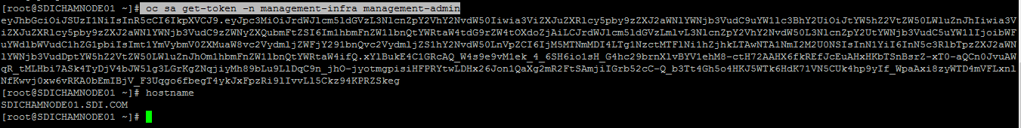

*Step 2: - Login to the CloudForms console*

*Username: - admin*

*Password: - smartvm*

***Click on compute 🡪 containers 🡪 Providers 🡪 configuration 🡪 Add a New Container Provider***

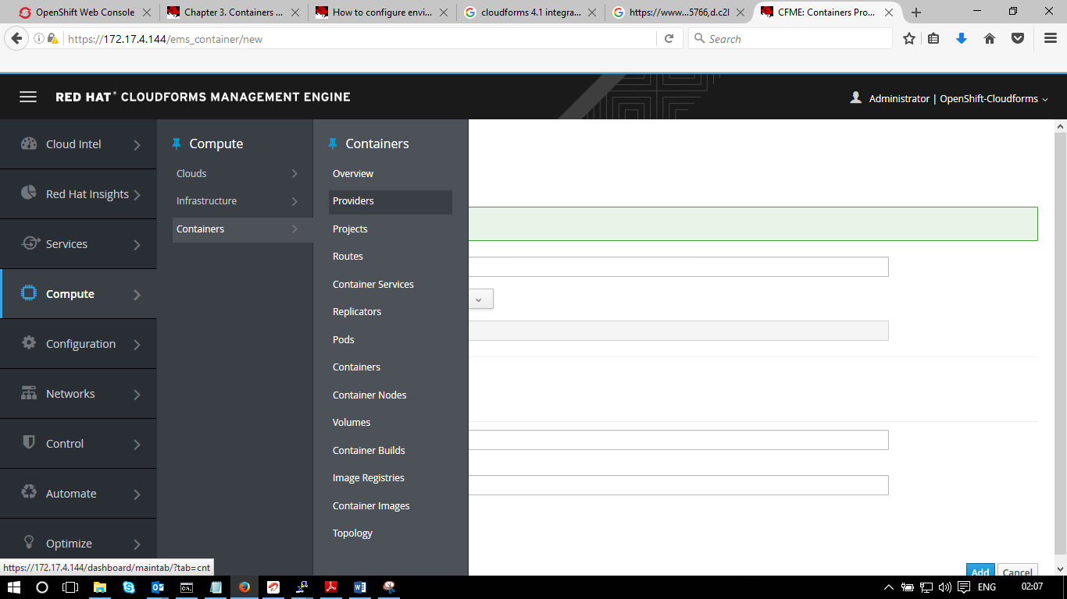

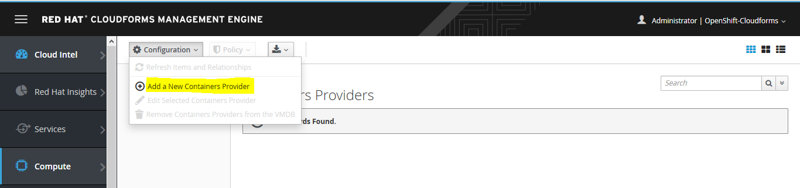

*Step 3: - Add the below details in the default tab and click on Add, it will show as credential successful.*

*Enter the token value which is generated above*

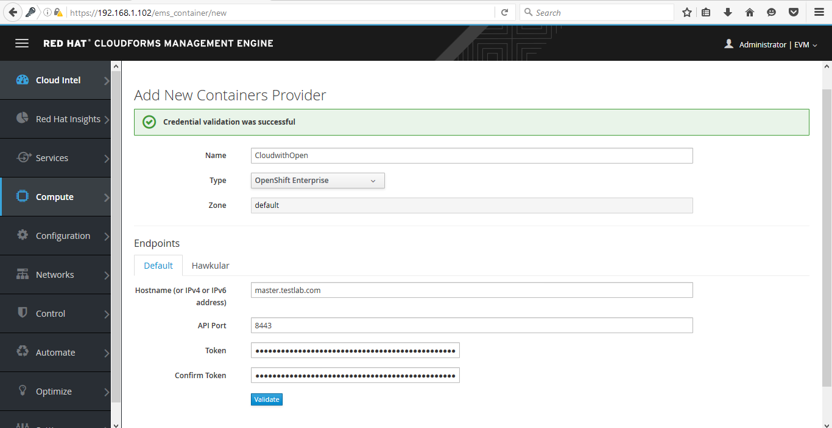

*Step 4: - Click on Hawkular and add the below details. Details might vary based on the URL link used for Hawkular.*

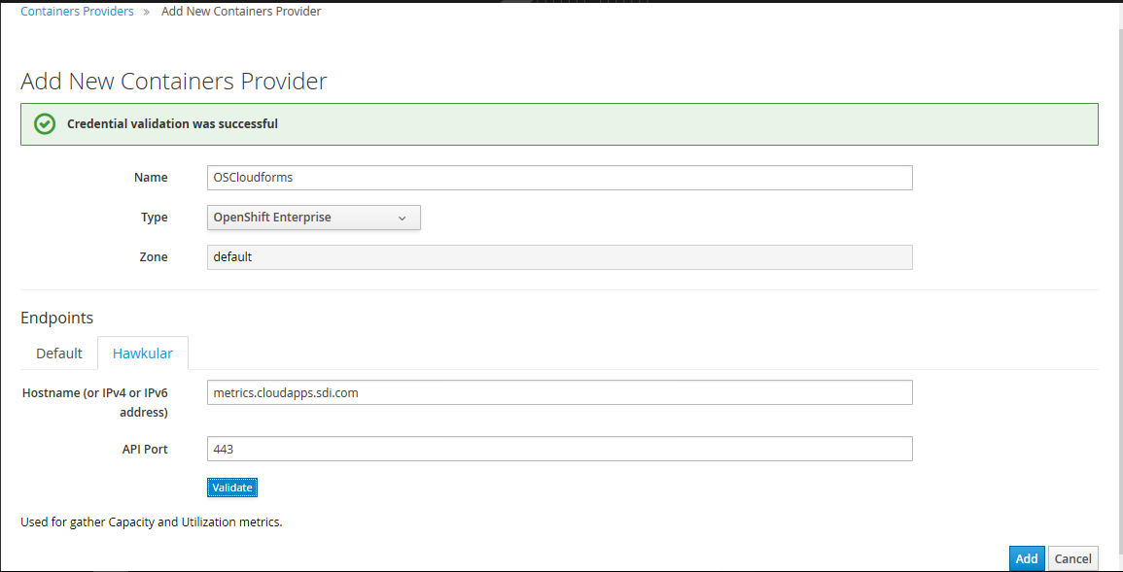

*Once it’s done click on add button on the bottom. screen will be show as below.*

